1-MNOs

🏢 What Are Licensed Mobile Network Operators (MNOs)?
# Source: Chatgpt (GPT-5-Mini) at [1/23/2026]
A Mobile Network Operator (MNO) — also known as a licensed mobile carrier or mobile service provider — is a company that owns and operates the infrastructure needed to provide mobile services such as voice, SMS, and data to users.
✅ MNOs are the big-name companies like Vodafone, Orange, AT&T, T-Mobile, Verizon, etc.

🧩 Key Characteristics of MNOs:
# Source: Chatgpt (GPT-5-Mini) at [1/23/2026]
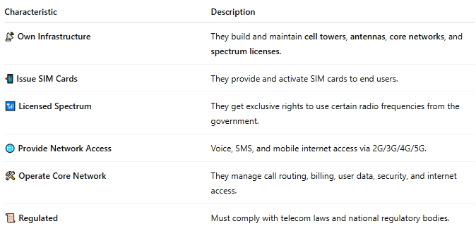

Characteristic | Description
📡 Own Infrastructure | They build and maintain cell towers, antennas, core networks, and spectrum licenses.
📲 Issue SIM Cards | They provide and activate SIM cards to end users.
📶 Licensed Spectrum | They get exclusive rights to use certain radio frequencies from the government.
🌐 Provide Network Access | Voice, SMS, and mobile internet access via 2G/3G/4G/5G.
🛠️ Operate Core Network | They manage call routing, billing, user data, security, and internet access.
📜 Regulated | Must comply with telecom laws and national regulatory bodies.

⚙️ What Do MNOs Manage?
# Source: Chatgpt (GPT-5-Mini) at [1/23/2026]
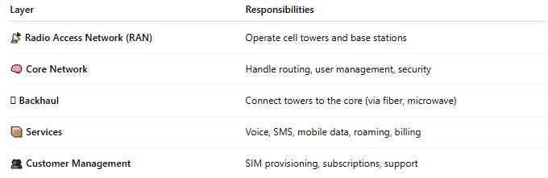

Layer | Responsibilities
📡 Radio Access Network (RAN) | Operate cell towers and base stations
🧠 Core Network | Handle routing, user management, security
🛜 Backhaul | Connect towers to the core (via fiber, microwave)
📦 Services | Voice, SMS, mobile data, roaming, billing
👥 Customer Management | SIM provisioning, subscriptions, support

🧾 Examples of MNOs:
# Source: Chatgpt (GPT-5-Mini) at [1/23/2026]
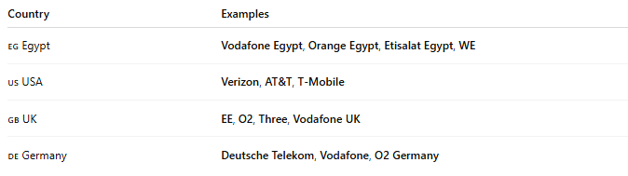

Country | Examples
🇪🇬 Egypt | Vodafone Egypt, Orange Egypt, Etisalat Egypt, WE
🇺🇸 USA | Verizon, AT&T, T-Mobile
🇬🇧 UK | EE, O2, Three, Vodafone UK
🇩🇪 Germany | Deutsche Telekom, Vodafone, O2 Germany

🆚 MNO vs MVNO:
# Source: Chatgpt (GPT-5-Mini) at [1/23/2026]
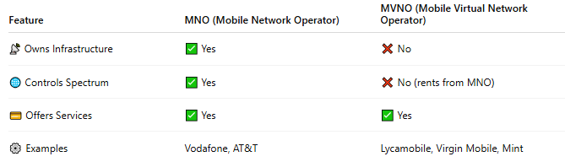

Feature | MNO (Mobile Network Operator) | MVNO (Mobile Virtual Network Operator)
📡 Owns Infrastructure | ✅ Yes | ❌ No
🌐 Controls Spectrum | ✅ Yes | ❌ No (rents from MNO)
💳 Offers Services | ✅ Yes | ✅ Yes
⚙️ Examples | Vodafone, AT&T | Lycamobile, Virgin Mobile, Mint

📖 Summary:
# Source: Chatgpt (GPT-5-Mini) at [1/23/2026]
A Mobile Network Operator (MNO) is a licensed company that builds and operates full mobile networks. They own the towers, frequencies, and systems needed to provide nationwide or global mobile services to users.

2-MVNO

📱 What Is an MVNO (Mobile Virtual Network Operator)?
# Source: Chatgpt (GPT-5-Mini) at [1/23/2026]
An MVNO is a Mobile Virtual Network Operator — a company that offers mobile services (calls, texts, internet) without owning its own network infrastructure. Instead, it rents access from traditional mobile network operators (MNOs) and resells it under its own brand.
🛍️ Think of an MVNO like a mobile service reseller — it uses another carrier’s network, but may offer different prices, plans, or customer service.

🧩 Key Characteristics of MVNOs:
# Source: Chatgpt (GPT-5-Mini) at [1/23/2026]
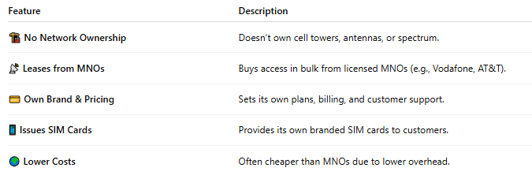
Feature | Description
🏗️ No Network Ownership | Doesn’t own cell towers, antennas, or spectrum.
📡 Leases from MNOs | Buys access in bulk from licensed MNOs (e.g., Vodafone, AT&T).
💳 Own Brand & Pricing | Sets its own plans, billing, and customer support.
📱 Issues SIM Cards | Provides its own branded SIM cards to customers.
🌍 Lower Costs | Often cheaper than MNOs due to lower overhead.

🔧 How MVNOs Work:
# Source: Chatgpt (GPT-5-Mini) at [1/23/2026]
- 📡 MNO provides the physical network (towers, backhaul, spectrum).
- 🤝 MVNO signs an agreement with the MNO to lease access.
- 📲 MVNO creates its own plans, pricing, and support system.
- 👤 Customers buy MVNO SIM cards and use mobile services like any other carrier.

🧾 Examples of MVNOs:
# Source: Chatgpt (GPT-5-Mini) at [1/23/2026]
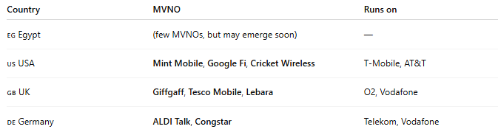

Country | MVNO | Runs on
🇪🇬 Egypt | (few MVNOs, but may emerge soon) | —
🇺🇸 USA | Mint Mobile, Google Fi, Cricket Wireless | T-Mobile, AT&T
🇬🇧 UK | Giffgaff, Tesco Mobile, Lebara | O2, Vodafone
🇩🇪 Germany | ALDI Talk, Congstar | Telekom, Vodafone

🆚 MVNO vs MNO:
# Source: Chatgpt (GPT-5-Mini) at [1/23/2026]
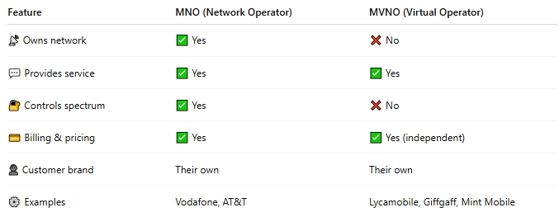

Feature | MNO (Network Operator) | MVNO (Virtual Operator)
📡 Owns network | ✅ Yes | ❌ No
💬 Provides service | ✅ Yes | ✅ Yes
🔐 Controls spectrum | ✅ Yes | ❌ No
💳 Billing & pricing | ✅ Yes | ✅ Yes (independent)
👤 Customer brand | Their own | Their own
⚙️ Examples | Vodafone, AT&T | Lycamobile, Giffgaff, Mint Mobile

✅ Benefits of MVNOs:
# Source: Chatgpt (GPT-5-Mini) at [1/23/2026]
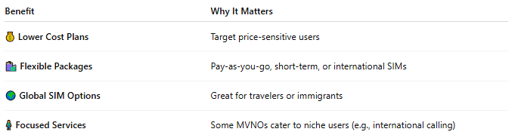

Benefit | Why It Matters
💰 Lower Cost Plans | Target price-sensitive users
🛍️ Flexible Packages | Pay-as-you-go, short-term, or international SIMs
🌍 Global SIM Options | Great for travelers or immigrants
🧍 Focused Services | Some MVNOs cater to niche users (e.g., international calling)

⚠️ MVNO Limitations:
# Source: Chatgpt (GPT-5-Mini) at [1/23/2026]
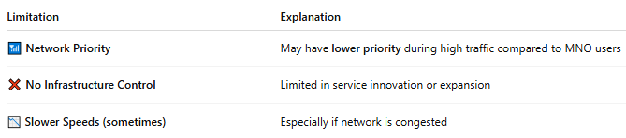

Limitation | Explanation
📶 Network Priority | May have lower priority during high traffic compared to MNO users
❌ No Infrastructure Control | Limited in service innovation or expansion
📉 Slower Speeds (sometimes) | Especially if network is congested

📖 Summary:
# Source: Chatgpt (GPT-5-Mini) at [1/23/2026]
An MVNO is a mobile provider without its own towers or spectrum, offering mobile services over another operator's network. MVNOs provide flexible, affordable alternatives to major carriers, especially in prepaid, low-cost, or international markets.

